Access to Information and Attitudes towards Intimate Partner Violence

In this exercise, we examine cross-national differences in attitudes towards domestic violence and access to information. We explore the hypothesis that there is an association at an aggregate level between the extent to which individuals in a country have access to knowledge and new information, both through formal schooling and through the mass media, and their likelihood of condemning acts of intimate partner violence. This exercise is in part based on:

Pierotti, Rachel. (2013). “[Increasing Rejection of Intimate Partner Violence: Evidence of Global Cultural Diffusion](http://dx.doi.org/10.1177/0003122413480363).” *American Sociological Review*, 78: 240-265.

We use data from the Demographic and Health Surveys, which are a set of over 300 nationally, regionally and residentially representative surveys that have been fielded in developing countries around the world, beginning in 1992. The surveys employ a stratified two-stage cluster design. In the first stage enumeration areas (EA) are drawn from Census files. In the second stage within each EA a sample of households is drawn from an updated list of households. In addition, the surveys have identical questionnaires and trainings for interviewers, enabling the data from one country to be directly compared with data collected in other countries. It is important to note that different groups of countries are surveyed every year.

In the study, the author used these data to show that “women with greater access to global cultural scripts through urban living, secondary education, or access to media were more likely to reject intimate partner violence.” The data set is in the csv file dhs_ipv.csv. The names and descriptions of variables are:

|  |  |
| --- | --- |
| Name | Description |
| beat_goesout | Percentage of women in each country that think a husband is justified to beat his wife if she goes out without telling him. |
| beat_burnfood | Percentage of women in each country that think a husband is justified to beat his wife if she burns his food. |
| no_media | Percentage of women in each country that rarely encounter a newspaper, radio, or television. |
| sec_school | Percentage of women in each country with secondary or higher education. |
| year | Year of the survey |
| region | Region of the world |
| country | Country |

Note that there are two indicators of *attitudes towards domestic violence*: beat_goesout and beat_burnfood. There are also two indicators of *access to information*: sec_school and no_media.

## Question 1

Let’s begin by examining the association between attitudes towards intimate partner violence and the two exposure to information variables in our data. Load the dhs_ipv.csv data set. Use scatterplots to examine the bivariate relationship between beat_goesout and no_media as well as between beat_goesout and sec_school. Repeat these bivariate graphs between beat_burnfood and no_media, as well as beat_burnfood and sec_school. Be sure to add informative axis labels. Briefly interpret these graphs in light of the hypothesis of the study.

## Answer 1

We see that the correlation of people who are not exposed to media and who think it is okay to beat the wife is slightly postively correlated while it is more strongly negatively correlated between beating being okay and more school completed. However, none of them shows a strong correlation.

domvio <- read.csv("/Users/clayparham/Documents/Bush631-/Assignment Five/dhs_ipv.csv")  
plot(domvio$beat_goesout, domvio$no_media, main = "No Media", xlab = "Beating Okay if she Goes Out", ylab = "No Media")

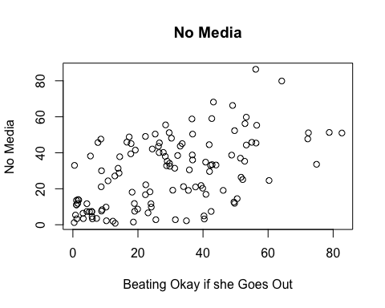

plot(domvio$beat_goesout, domvio$sec_school, main = "Sec School", xlab = "Goes Out", ylab = "Secondary School")

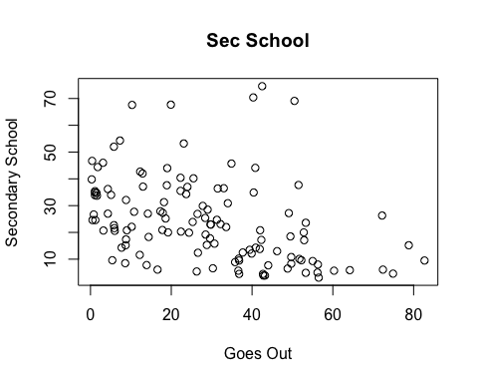

plot(domvio$beat_burnfood, domvio$no_media, main = "Burn Food", xlab = "Beating Okay if she Burns Food", ylab = "No Media")

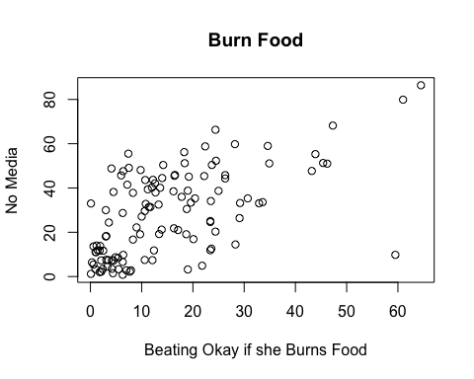

plot(domvio$beat_burnfood, domvio$sec_school, main = "Burn Food", xlab = "Goes Out", ylab = "Secondary School")

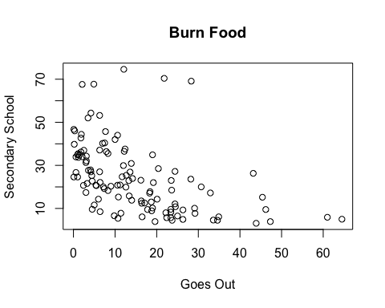

## Question 2

Compute the correlation coefficient between beat_burnfood and media exposure, as well as between beat_burnfood and education. Remember to use complete observations. What do these measures tell us about the association between education and media exposure with attitudes towards intimate partner violence?

## Answer 2

It shows that there is a somewhat high positive correlation between media exposure and domestic violence. This means that as media exposure decreases, domestic violence increases. The inverse is true for schooling; more schooling means less acceptance for domestic violence.

cor(domvio$beat_burnfood, domvio$no_media, use = "pairwise")

## [1] 0.5967618

cor(domvio$beat_burnfood, domvio$sec_school, use = "pairwise")

## [1] -0.4760835

## Question 3

We proceed to explore the national-level differences in attitudes towards domestic violence. First, use boxplots to compare the variation in the percentage of beat_burnfood between different regions of the world using region. What are the main differences across regions in terms of the median and dispersion of the distribution? Second, using boxplots examine the distribution of no_media and sec_school by region of the world. Comment on the main differences of the distribution of these variables across regions.

## Answer 3

Other than what’s already been said about correlation, we see that the quartile differences between the regions closely follow each other across all the variables. For example, sub-Sarahan Africa has a wide range in which values can lay on all the boxplots, while Latin America is somewhat tight in differences between all the plots.

boxplot(beat_burnfood ~ region, data = domvio,  
 main = "National-Level Differences",  
 ylab = "Burning Food")

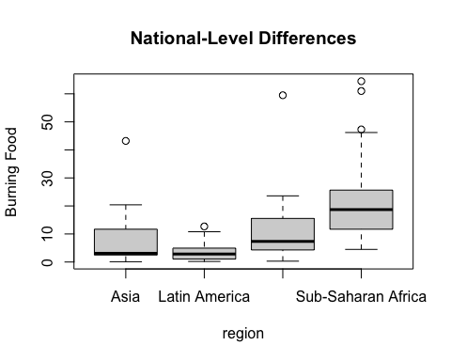

boxplot(no_media ~ region, data = domvio,  
 main = "National-Level Differences",  
 ylab = "No Media")

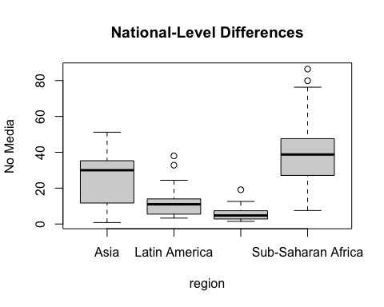

boxplot(sec_school ~ region, data = domvio,  
 main = "National-Level Differences",  
 ylab = "Secondary Schooling")

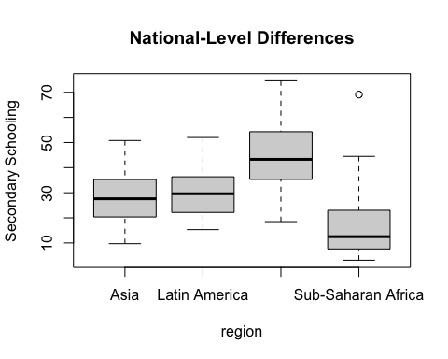

## Question 4

An important point of the researcher’s hypothesis is that the support towards intimate partner violence should *decrease* over time, as more women across regions have access to formal schooling and exposure to mass media. To test this idea, using time-series plots, examine the trends in beat_burnfood from 1999-2014 *within each region*. Thinking about the study design, what should we consider before trusting that this plot shows a change over time in attitudes?

## Answer 4

I think that the things that lead to decreases in attitudes towards domestic violence take a long time to percolate through a population, so the 15 years is not enough time to see meaningful change. Additionally, there is some social desireability bias in the data - internal thoughts may not be as truthfully said as education increases and respondents know they are in the wrong.

asia <- subset(domvio, region == "Asia")  
lam <- subset(domvio, region == "Latin America")  
africa <- subset(domvio, region == "Sub-Saharan Africa")  
me <- subset(domvio, region == "Middle East and Central Asia")  
tapply(asia$beat_burnfood, asia$year, mean)

## 2000 2001 2002 2003 2004 2005 2006 2007 2008 2009 2010 2011 2012   
## NA 5.00 NA 3.10 NA NA NA NA 2.10 24.75 13.30 2.10 10.45   
## 2013 2014   
## 1.80 11.70

tapply(lam$beat_burnfood, lam$year, mean)

## 2000 2001 2002 2003 2004 2005 2007 2008 2009 2010 2011 2012 2013   
## NA 4.5 2.4 5.4 0.6 NA 1.1 3.3 2.7 0.8 2.6 5.8 0.6

tapply(africa$beat_burnfood, africa$year, mean)

## 1999 2000 2001 2002 2003 2004 2005 2006   
## 12.00000 NA 36.06667 29.10000 NA NA NA 24.42000   
## 2007 2008 2009 2010 2011 2012 2013 2014   
## NA 12.66667 NA NA NA NA 14.95000 20.10000

tapply(me$beat_burnfood, me$year, mean)

## 2000 2002 2003 2005 2006 2007 2008 2009   
## NA 59.500000 NA 8.433333 12.100000 7.700000 6.150000 NA   
## 2010 2012 2013 2014   
## 0.300000 4.050000 9.700000 7.000000

lam_dvtrend <- tapply(lam$beat_burnfood, lam$year, mean, na.rm = TRUE)  
asia_dvtrend <- tapply(asia$beat_burnfood, asia$year, mean, na.rm = TRUE)  
africa_dvtrend <- tapply(africa$beat_burnfood, africa$year, mean, na.rm = TRUE)  
me_dvtrend <- tapply(me$beat_burnfood, me$year, mean, na.rm = TRUE)  
  
plot(me$year, me$beat_burnfood, type = "n", main = "Support Towards Violence Over Time", ylab = "Violence Okay", xlab = "Time")  
  
#points(lam$year, lam$beat_burnfood) + points(africa$year, africa$beat_burnfood) + points(asia$year, asia$beat_burnfood) +   
  
points(names(lam_dvtrend), lam_dvtrend, type = "l", col = "red") + points(names(asia_dvtrend), asia_dvtrend, type = "l", col = "blue") + points(names(me_dvtrend), me_dvtrend, type = "l", col = "dark green") + points(names(africa_dvtrend), africa_dvtrend, type = "l", col = "gold")

## integer(0)

text(2003, 10, labels = "Latin America", col = "red") + text(2003, 15, labels = "Middle East", col = "green") + text(2001, 20, labels = "Africa", col = "gold") + text(2003, 5, labels = "Asia", col = "blue")

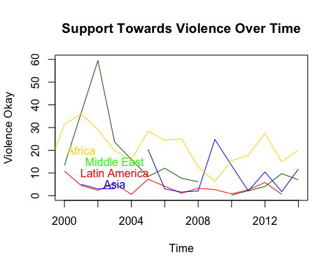

## integer(0)